Colva Union UK

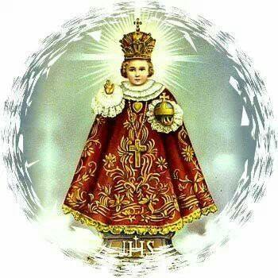

Notice of Annual General Meeting

Date: Saturaday 16 May 2015.
Time: 430pm
Venue: Pope John Centre. Our Lady Queen of Apostles Church, Heston.
15 The Green, Heston Road, Heston, Middx TW5 0RL.

Agenda

1.Approve minutes of the last AGM
2.Approve accounts for last year
3.Elections of new committee members
4. Discuss 2015/16 – Calendar of events
5.Planning of 42nd Anniversary Celebrations
6.Discuss Christ the King Statue in Colva Goa matters
6.Any other matters that May Arise.

We look forward to villagers of Colva Goa in attending this AGM

To confirm your attendance and also for membership details please contact our President Gabriel Fernandes on e mail: fernandesgabriel2000@yahoo.com

Please also visit our Facebook website:Colvaunionuk Goa

